Street Level Photoworks and Artlink Artist Exchange
‘On the Edge’ – Residency Opportunity at Fort Dunree, Donegal, Ireland.
2019/2020 marks a cultural exchange between Glasgow and Donegal. There is an ongoing historical relationship with the people of Scotland, particularly Glasgow, and the people in the North west of Ireland, particularly Donegal. Economic migration has embedded familial ties, cultures, language and music as well as a tacit understanding of each others' nature. Through this exchange programme we are opening up opportunities to explore, amongst other things; historical and contemporary cultural and economic links, landscape and place-making, the ‘remote’ and the ‘centre’, as well as the sustainability of communities in rural and urban areas.
Street Level Photoworks in collaboration with Artlink (Ireland) are delighted to announce an exchange residency with an open call to photographers or artists working with photography for a one-month residency to take place in Ireland between October 2019 and March 2020.
A reciprocal residency will see an Irish artist undertake a residency in Scotland for one month between April 2020 and December 2020.
Residency Structure
This opportunity includes a funded one-month stay for one photographer from Scotland in Ireland through Artlink (which will be reciprocated with an artist from Donegal in Scotland in 2020). The recipient partner will offer time, space and professional support for work, reflection, research and experimentation.
The artist is expected to deliver a public presentation, talk or workshop as part of their residency at the host venue. They will also participate in a public talk at Street Level in 2020 alongside the Irish artist at the conclusion of that reciprocal residency. It is hoped that further creative dialogue between the artists will increase knowledge exchange and influence, where appropriate, any residency outcomes. It is expected that work arising from the residency will be developed in exhibition form as part of a curated group show in the future.
As well as creating a space for ideas, there is an expectation that part of the residency involves networking and meetings of introduction with others in the photography sector of the host country in order to help enlarge awareness of artistic practice around photography in Scotland and Ireland.
Dates for Scottish artist in Donegal: for one month between October 2019 - February 2020 (precise dates TBC). It is possible to split the residency so that an initial research period is followed up with a more practical based on, for example. In this instance, additional travel will be the responsibility of the artist.
In line with our environmental policy, we recommend that land and sea are used for travel. Street Level and Artlink can advise further.
Please note that a call for the Irish artist in Scotland will be made in early 2020
Information on Host Organisation
Artlink is a successful artist lead visual artists organisation, currently based in the impressive cliff top location of Fort Dunree. Artlink supports the ambitions and profile of local, national and international artists by providing a platform for innovative delivery and realisation of projects such as our solo show programme and residenices. Artlink successfully manages a residency programme through which artists have the opportunity to research, experiment and create new original work and contribute to the creative development of the local arts community. Through a programme of residencies, exhibitions, workshops and community projects, in the raw coastal context of Fort Dunree, Artlink forges local, national and international partnerships to build a strong sustainable culture and contribute to the artistic and economic ecology of the region.

More information on Artlink here: http://www.artlink.ie/programme.html

Guidelines

Fees & Support

Scottish Artist in Donegal
Artilink will offer time, space and professional support for work, reflection, research and experimentation. Facilities available
- Links to the local community
- 24-hour secure access to studio space (if required)
- Broadband Internet (intermittent)
- Alternative photographic processing kit (hinged back printing-out frames 1 x 20”x16”, 4 x 12”x16”, UV light, flat hake brushes, weighing scales, thermometers, glass cylinders, developing trays up to 20 x 16, print washer)
- Digital Imaging Suite
- Colour Printer
- Technical assistance
- “The Potting Shed” community garden and studio
- Digital projector
- Large flat screen monitor

Fees: The residency opportunity covers fee, accommodation and travel.
Residency fee is £2700 which is inclusive of per diems and on site travel. This also includes rights for any public display of outcomes, whether in digital or exhibition form.
£200 travel from Glasgow to Artlink Studios Donegal. [Should the selected artist choose to split their residency period then they are responsible for the additional travel between Scotland and Ireland.]
Accommodation is included on top of the fee and is provided by Artlink (please note accommodation is off-site).

Eligibility
• The residencies are aimed at committed photographers with a developed and serious approach to their work.
• Must be resident in Scotland.
• The successful artists must take out medical insurance for the duration of their residency and ensure their own equipment is adequately covered by insurance.
• The successful artists must submit a report on completion.

Exclusions
• Students and those in Further Education are not eligible.

Selection
• For the Donegal residency, completed application forms and supporting images should be emailed or sent by We Transfer only to: exhibitions@streetlevelphotoworks.org with the subject title: SLP / Artlink Application.
• The selection of the artists will be made by representatives of Artlink.
• Please adhere to the image size guidelines in the application form.
Deadline for submission of applications with all support material: 30th August 2019 at midnight.
We expect to announce the selection by mid-September.
This residency is part of ‘On the Edge’, a project aimed at cooperation between Scotland and other European countries through cultural dialogue, knowledge exchange and tangible outcomes for artists and the public. It is supported by British Council Scotland and Creative Scotland.

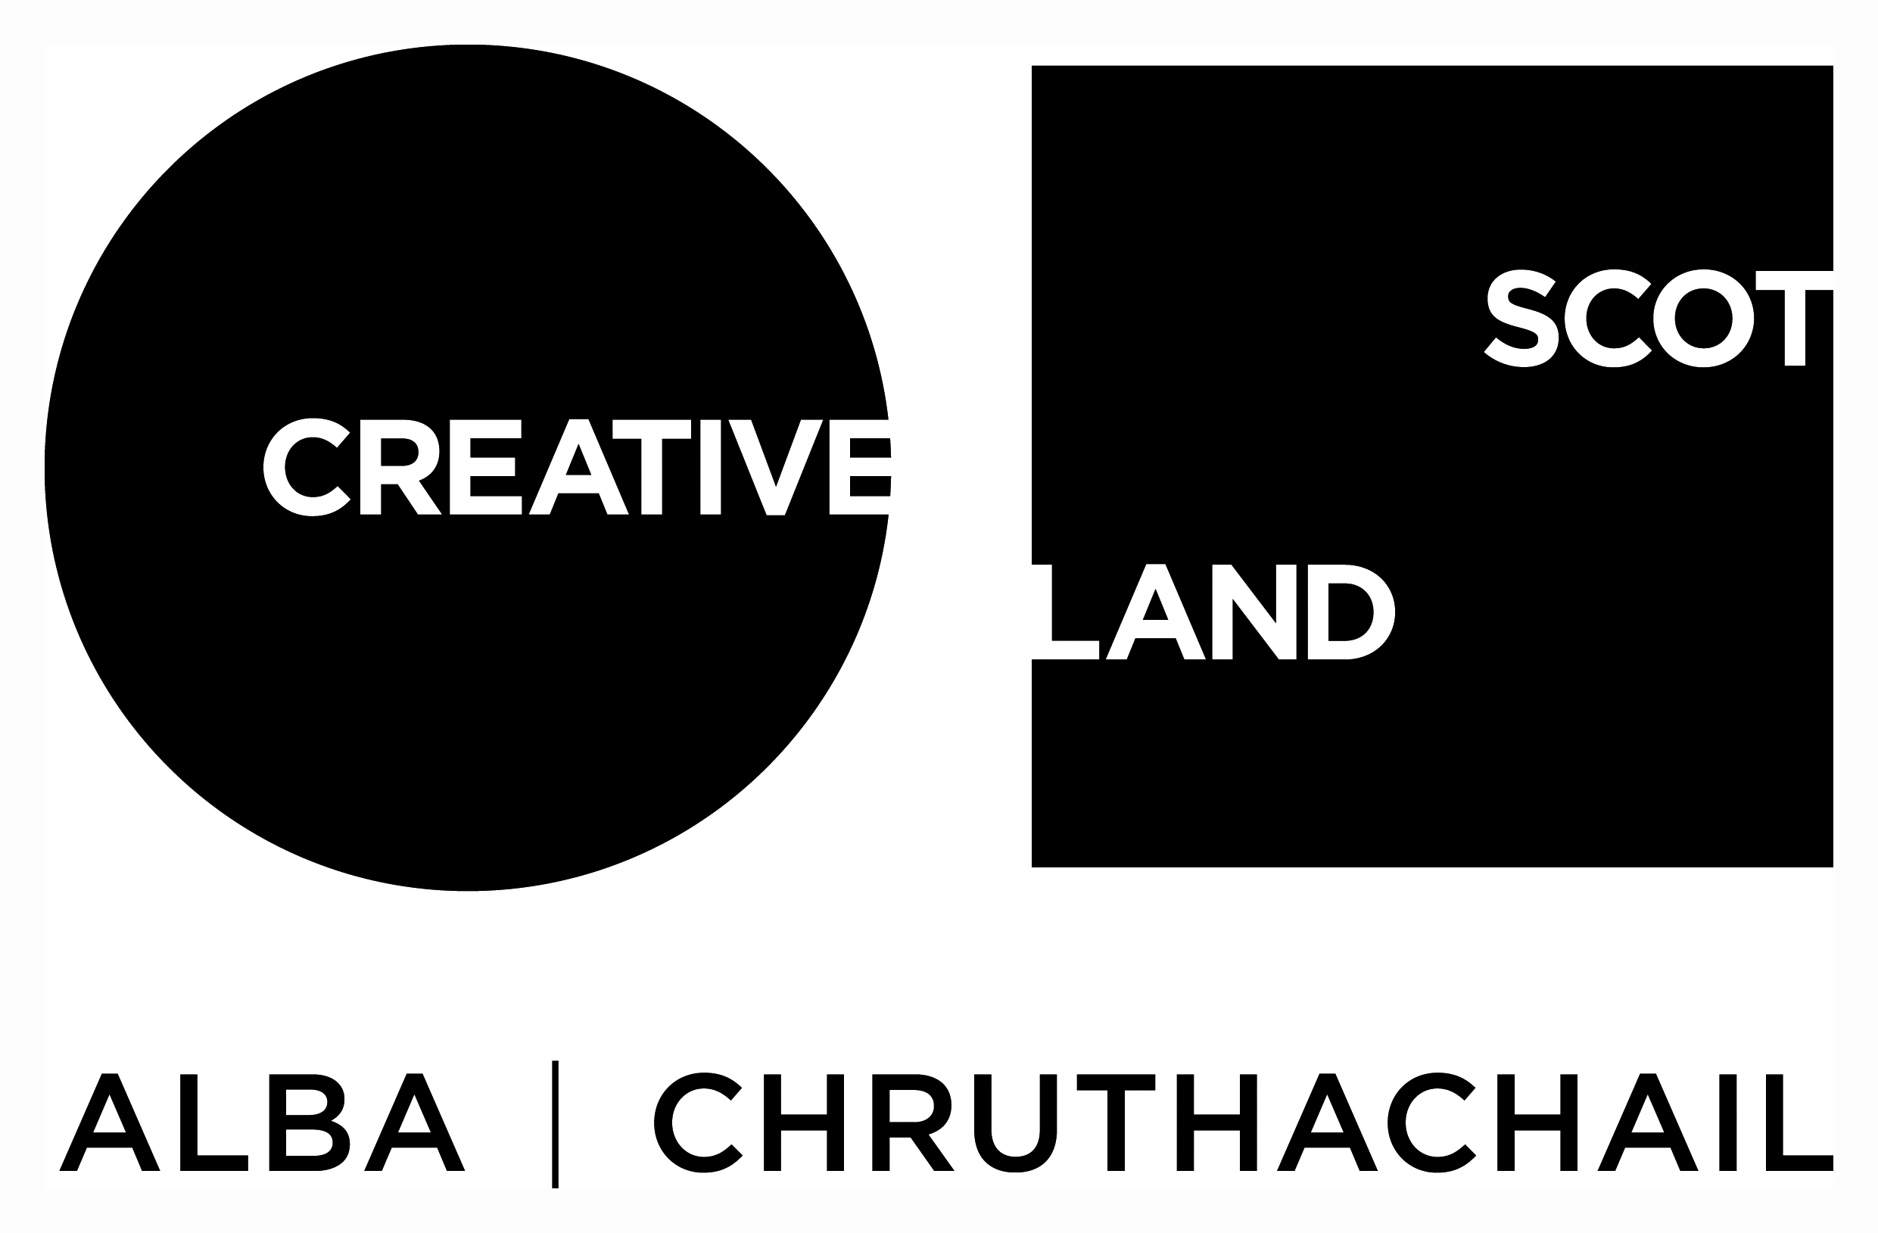
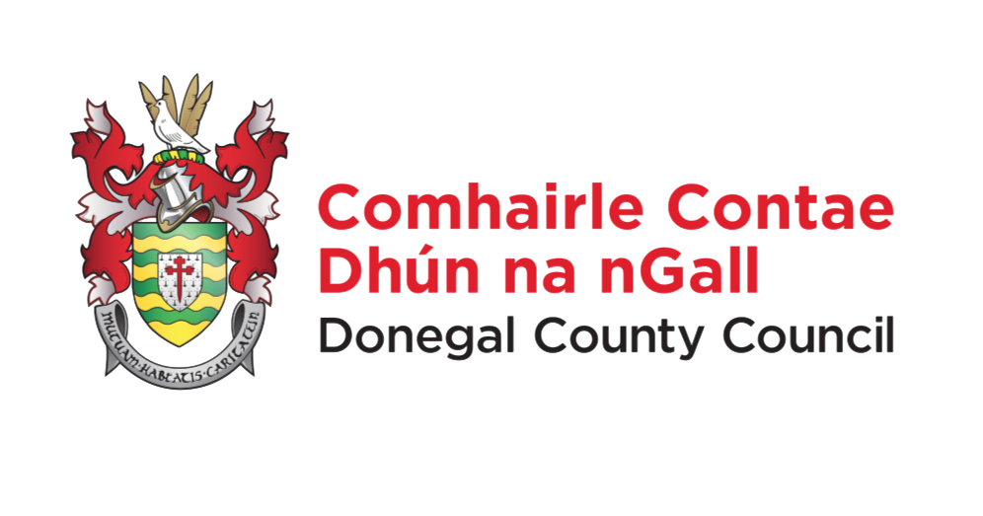
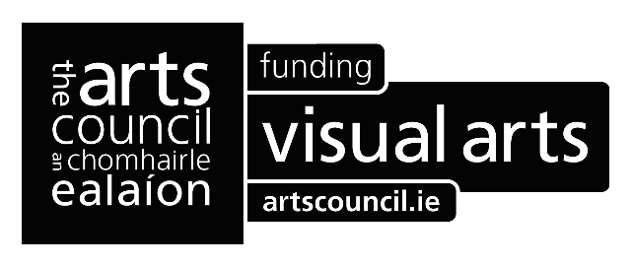
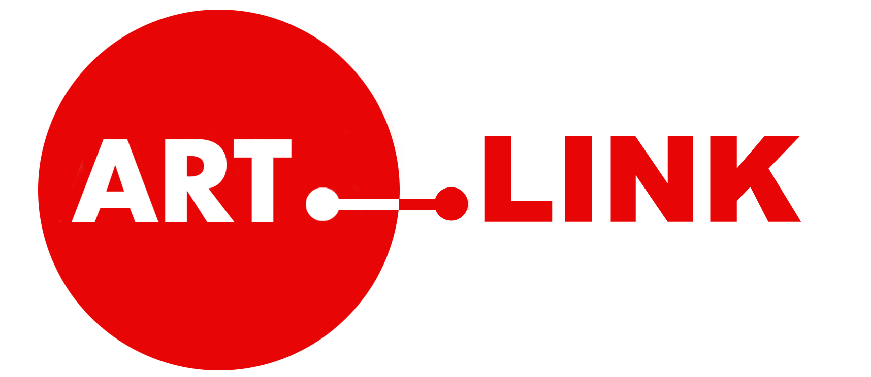
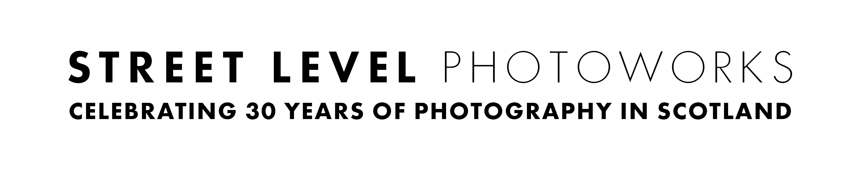
Application Form

Please fill out all the fields listed below:

- Full Name:
- Date of Birth (dd/mm/yy):
- Place of Birth (City, Country):
- Nationality or Country that Issued your current Passport:
- Where do you currently reside:
- Email Address:
- Telephone Number:
- Mailing Address:
- Please provide a summary biography of your artistic and professional work, this is separate to your CV supplied additionally with the application (max 100 words):
- Please provide a short statement on your practice, (max 100 words):
- Please explain what you hope to gain from the residency, any themes you might want to pursue, and how this opportunity will contribute to your practice, (max 300 words):
- How, or from where, did you hear about this opportunity l?
- Have you carefully read all information in this application form, including eligibility, exclusions and selection?

Please sign and date (print name):

Name:

Date:

(by printing your name this confirms that all the information you have given is correct and that you have read the application guidelines)

Please attach the following to your application:

• no less than 6 and no more than 10 sample images of your work at 1920 pixels on the wide side and at 72 dpi (JPEG, PNG or PDF).
- two links to moving image works or other relevant online references which strengthen your application can be provided, but this is not essential. If supplying these then please ensure the link provided is active and is a direct link to the work or sequence in question.

• Please name each image with the following ‘your name_title_year_1’. Please also supply a list of these also with corresponding numbers as part of the application.

• A CV detailing your education, professional experience, exhibitions and project, plus any commissions, residencies or awards (no more than 1 page).

PLEASE NOTE: failure to meet these specfications regarding image submission may result in your application being disqualified.

In line with our Environmental Policy, these should be sent via e-mail or WeTransfer only. Please put all images in one folder, titling the folder with your name.

