Street Level Photoworks and Northern Photographic Centre Artist Exchange
‘On the Edge’ – Residency Opportunity in Oulu, Finland.
2019/2020 marks a photographic exchange between Finland and Scotland. There are many connections between the countries in terms of population, geography and the traditional industries of shipbuilding and engineering. Through this exchange programme we are opening up opportunities to explore, amongst other things; commonalities, both historical and contemporary, indigenous cultures, the relationship of the ‘remote’ to the ‘centre’, landscape and placemaking, and the sustainability of communities in rural and urban areas.
As part of this, Street Level Photoworks in collaboration with Northern Photographic Centre (Oulu) are delighted to announce an open call to Photographers and Artists working with photogrpahy for a one month residency to take place in Finland between February and March 2020.
Residency Structure
This opportunity includes a funded one-month stay for one photographer from Scotland in Finland. The recipient partner will offer advice and professional support in order for the resident artist to pursue research and experimentation.
The artist is expected to deliver a public presentation, talk or workshop as part of their residency at Northern Photographic Centre. They will also participate in a public talk at Street Level in later 2020 to share residency outcomes/work in progress. It is expected that work arising from residency will be developed in exhibition form as part of a curated group show in the future.
As well as creating a space for ideas, there is an expectation that part of the residency involves networking and meetings of introduction with others in the photography sector of the host country in order to help enlarge awareness of artistic practice around photography in Scotland and Finland. For that purpose, it is expected that approximately 3 days will also be spent in Helsinki in the commencement of the residency.
Dates for Scottish artist in Finland: for one month between February 2020 and end of March 2020 (precise dates TBC).
Information on Host Organisation
The Northern Photographic Centre is a regional photographic centre established in 1987 to operate in the Northern regions of Finland, Oulu district and Lapland. It is based in the Cultural Centre named Valve. It is one of ten photography centres across Finland, in addition to the Finnish Museum of Photography and Hippolyte, the gallery of the Union of Photographers.
The main function of the photographic centre is to promote and develop photographic art and culture in the region. The centre organises exhibitions of Finnish and international photographic art. In addition to the exhibitions the Northern Photographic Centre organises and coordinates photography workshops, seminars and various projects exploring photographic art.
The activities of The Northern Photographic Centre are targeted for anyone interested in photography and visual culture.
More information here: www.photonorth.fi

Guidelines

Fees & Support

Scottish Artist in Oulu, Finland
Northern Photographic Centre will offer time, space and professional support for work, reflection, research and experimentation. Street Level will provide advance contacts and introductions to follow up, where relevant.
Northern Photographic Centre will also provide the following:
- Regular contact and guidance; contacts and introductions to photographers and artists in the North of Finland;
- advice and assistance with subject matter/shooting locations if necessary, people, places, etc.
- temporary studio use for any portrait or other studio based photography;
- assistance in finding accommodation in Lapland or further North should that be relevant to the research.
- access to their library.
Fees: The residency opportunity covers fee, per diems, accommodation and travel.
Residency fee is £2000; travel costs of £350*; per diems of £700; plus accommodation. The fee is inclusive of rights for any public display of outcomes, whether in digital or exhibition form.
* where additional internal travel is required and where it exceeds the travel budget amount then the resident artist is responsible for this from the available budget.

Eligibility
• The residencies are aimed at committed photographers with a developed and serious approach to their work.
• Must be resident in Scotland.
• The successful artists must take out medical insurance for the duration of their residency and ensure their own equipment is adequately covered by insurance.
• The successful artists must submit a report on completion.

Exclusions
• Students and those in Further Education are not eligible.

Selection
• Completed application forms and supporting images should be emailed or sent by We Transfer only to: exhibitions@streetlevelphotoworks.org with the subject title: Scotland/Finland Application.
• The selection of the artists will be made by a panel comprising of representatives of Street Level and Northern Photographic Centre.
• Please adhere to the image size guidelines in the application form.
Deadline for submission of applications with all support material: 30th August 2019 at midnight.
We expect to announce the selection by mid-September.
This residency is part of ‘On the Edge’, a project aimed at cooperation between Scotland and other European countries through cultural dialogue, knowledge exchange and tangible outcomes for artists and the public. It is supported by British Council Scotland and Creative Scotland.

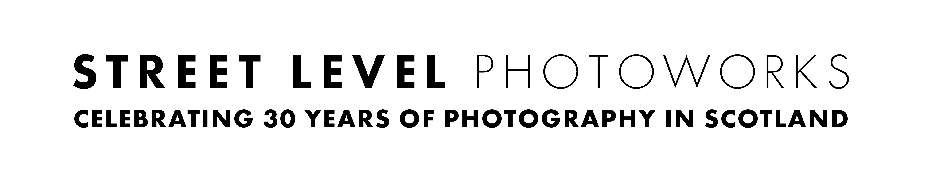
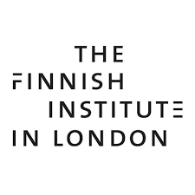
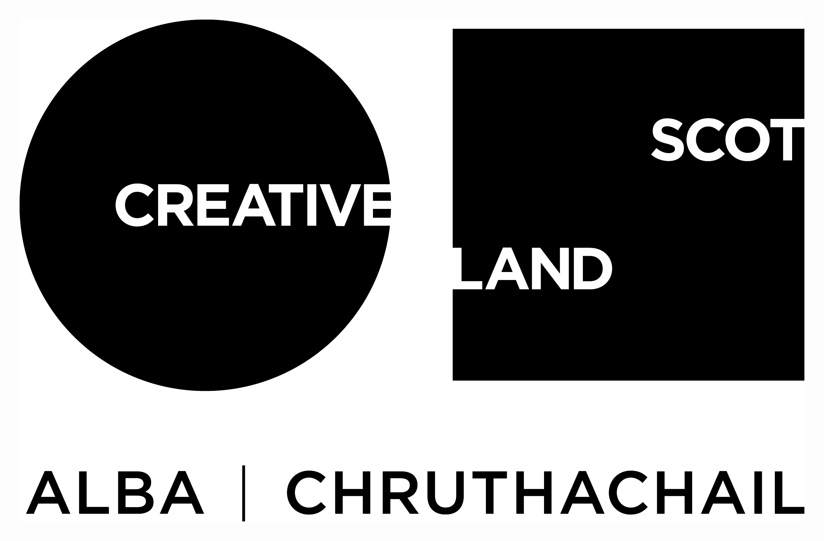
Application Form

Please fill out all the fields listed below:

- Full Name:
- Date of Birth (dd/mm/yy):
- Place of Birth (City, Country):
- Nationality or Country that Issued your current Passport:
- Where do you currently reside:
- Email Address:
- Telephone Number:
- Mailing Address:
- Please provide a summary biography of your artistic and professional work, this is separate to your CV supplied additionally with the application (max 100 words):
- Please provide a short statement on your practice, (max 100 words):
- Please explain what you hope to gain from the residency, any themes you might want to pursue, and how this opportunity will contribute to your practice, (max 300 words):
- How, or from where, did you hear about this opportunity l?
- Have you carefully read all information in this application form, including eligibility, exclusions and selection?

Please sign and date (print name):

Name:

Date:

(by printing your name this confirms that all the information you have given is correct and that you have read the application guidelines)

Please attach the following to your application:

• no less than 6 and no more than 10 sample images of your work at 1920 pixels on the wide side and at 72 dpi (JPEG, PNG or PDF).
- two links to moving image works or other relevant online references which strengthen your application can be provided, but this is not essential. If supplying these then please ensure the link provided is active and is a direct link to the work or sequence in question.

• Please name each image with the following ‘your name_title_year_1’. Please also supply a list of these also with corresponding numbers as part of the application.

• A CV detailing your education, professional experience, exhibitions and project, plus any commissions, residencies or awards (no more than 1 page).

PLEASE NOTE: failure to meet these specfications regarding image submission may result in your application being disqualified.

In line with our Environmental Policy, these should be sent via e-mail or WeTransfer only. Please put all images in one folder, titling the folder with your name.

